The IC control head Performance Script

Instead of explaining or “detailing” the IC control Head......Put on a Performance. Confident people don’t “explain” or “detail”..........they enjoy being looked at, and they PERFORM! Here is your script! 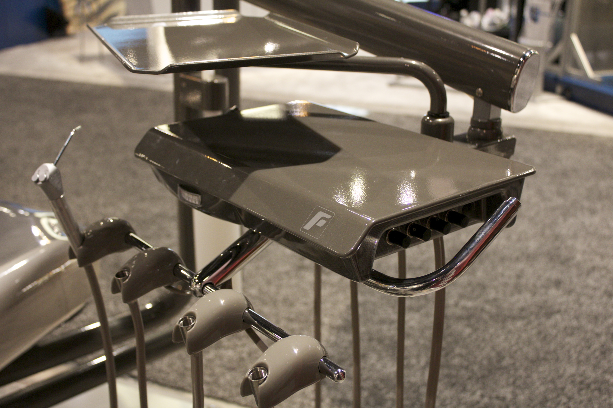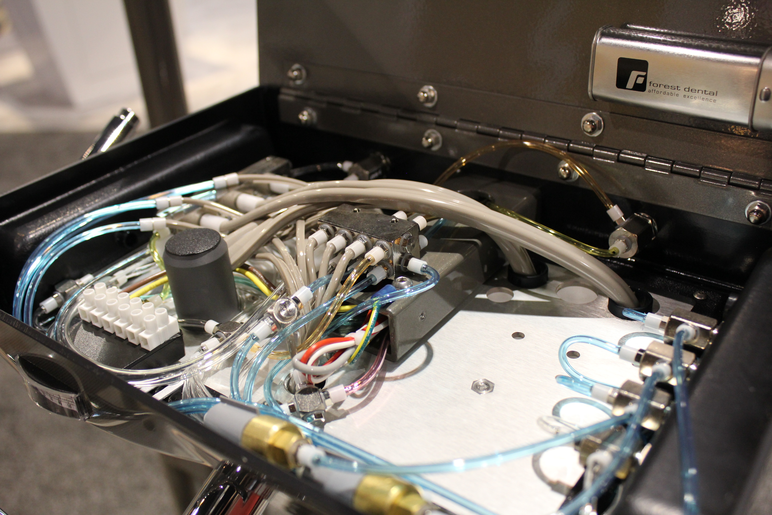
Take Forest’s brand strategy......and mention it...Affordable excellence, (pause).. Designer Friendly.......take these 2 simple ideas....and use them as a mental model to outline our confident performance....

“Forest is one if the fastest growing dental companies in North America. They are known for their color and chrome....but there is so much more. The company lives and breathes it’s brand strategy....Affordable Excellence and Designer Friendly.”

AffordableExcellence-
-Needle bearings in the pivot-radius joint....done right! NO sag.
-very little plastic...Forest known for it’s beautiful metal aesthetic appeal
-3 anti-retraction clippard valves..service techs love because they are dependable and available
-a control block which is a “thick affair”...and gives the mist control water valve on the high speed.....it gived YOU...Doctor....tons of range in terms of your water control knob
-all metal “T’s”....maybe the only dental company left in North America that uses metal T’s
-simple.....doc could almost repair it his or herself....in fact...a tool kit in the control head to adjust drive air, etc.
-LIFETIME warranty under the hood.....5 years on the whole unit.
Designer Friendly-
-chrome end caps
-9 powder coat colo choices that are no charge!
-3 carbon fiber accent looks
- color choices that are natural, often dark,....giving you that “Starbucks effect” People don’t just walk into starbucks for the coffee....it’s the relaxing....atmosphere.

If you want to put it on an existing chair...we will give you the chair adapter at no charge!

